Skills Workshop #3: Seminar on Using Library Facilities at CEAS Library
Speaker: Ted Baldwin M.L.S, Director of the Science and Engineering Libraries
Date: Wednesday, June 14, 2017
Time: 4:00 – 5:00pm
Venue: University of Cincinnati, CEAS Library Conference Room

Prepared by:
Tiara Anderson, Purcell Marian High School, Cincinnati, Ohio
RET Participant for Project #2: Energy Storage Devices Based on Three Dimensional (3D) Graphene: Case Supercapacitors and Lithium- Sulfur (Li-S) Batteries

This session was given by Ted Baldwin, Director of the Science and Engineering Libraries of the University of Cincinnati on Wednesday, June 14, 2017 from 4:00-5:00pm at the University of Cincinnati in College of Engineering and Applied Science (CEAS) Library in the conference room. At the start of the session, Mr. Baldwin introduced himself as well as Hong Cheng the Global Services Librarian. Mr. Baldwin then directed us to the CEAS Library Guide for RET, found on the CEAS library website. Figure 1 shows Mr. Baldwin referring the library guide, as it was used as was used as a schedule for the workshop presentation.

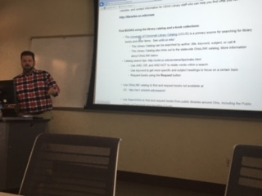
Figure 1: Ted Baldwin displaying CEAS Library Guide for RET

Mr. Baldwin first provided general information about the library including hours of operation, procedure for checking out books, and the link for the proxy log in to access the CEAS Library database off campus. The CEAS Library is one of 11 libraries on campus. This particular library serves engineering students by providing research resources specific to engineering fields in various forms. These include but are not limited to books, scholarly articles, scientific journals, e-books, links to helpful websites, conference papers, reviews, and electronic government documents. Mr. Baldwin then explained the process to find, retrieve and use these many resources along with helpful user tips.

The primary source for searching for library books and other items is the University of Cincinnati Library Catalog (UCLID). The library catalog searches all libraries on campus and also all universities in Ohio using OhioLINK. A resource can be searched by author, title, keyword or call number. A resource can also be requested through SearchOhio, which searches public libraries around Ohio. E-books may be found through the library catalog and also Proceedings Online, a database that provides the requested e-book through the publisher’s own website. Wiley Online Library, Knovel, and CRCnetBASE are e-book databases that provide material for all subjects. Other e-book databases are focused on particular subjects such as Aerospace Research Central (aerospace), SPIE Digital (optical and electrical engineering, physics) and ASCE proceedings (civil engineering).

Mr. Baldwin then showed RET participants how to access resources aside from published books. Researchers can access scientific journals using a tool called “Full Text Journals” and search by journal title, ISSN, other journal information or by browsing an alphabetical list. Researchers can also access journals that are not available at UC through Interlibrary Loan (ILLIAD) or journals that are public or available through an outside source (i.e. ResearchGate) using Google Scholar. Google Scholar also provides scholarly research from all areas although it is not comprehensive.

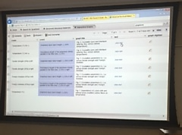 | 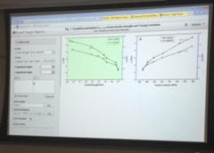
Figure 2: Knovel Interactive Graph Options | Figure 3: Knovel Interactive Graph with Variables

Research article databases Mr. Baldwin highly recommended include Scopus and Compendex. In addition to engineering fields, Scopus provides a comprehensive search through all sciences including humanities, social sciences and psychology. One can confine the search of articles using the year, author, and subject area but also by document type. These include articles, conference papers, article and press, book chapter, conference review or even a short survey. Also, the database relates important information about the source including the number of times it has been cited, related documents, the author’s keywords, basic information about chemicals referenced in the text and CAS registry numbers.

Towards the end of the workshop, Mr. Baldwin displayed how Knovel (aforementioned research database) even provides interactive graphs. Listed as a technical reference, the researcher can choose an interactive graph that is provided as shown in Figure 2. The tool allows for variable manipulation and adjusts the graph as the variables are adjusted as shown in Figure 3. It was evident that Mr. Baldwin desired to communicate the expansive range of resources available to those in search of information.

